Spring Lane/Sussex Ave junction
This junction in Canterbury (and others like it) often catch drivers out, particularly on test.
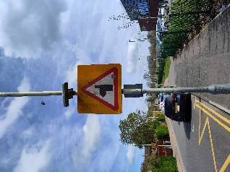
This sign clearly shows that the major road (the thick line) takes a sharp left turn, with a minor road (the thin line) coming off it on the right-hand side. If you don’t see the sign then you might think that the major road continues straight ahead (as in the picture below). Failing to acknowledge the curve in the road and driving straight ahead will put you in significant danger of a collision with vehicles approaching on the major road from the left.

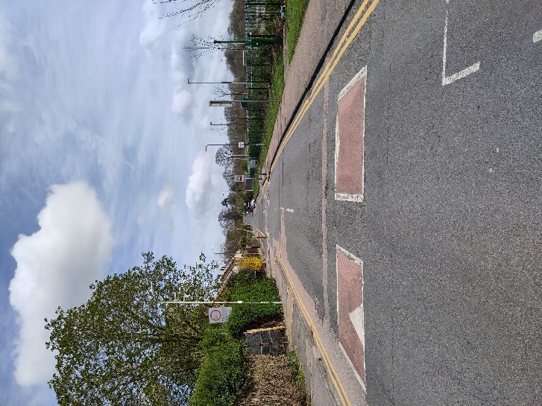
This picture shows the drivers view, approaching the corner. At this point unobservant drivers may think the road continues in a straight line. However, as the sign showed, the major road curves sharply left, shown by the arrow.

Sussex Avenue

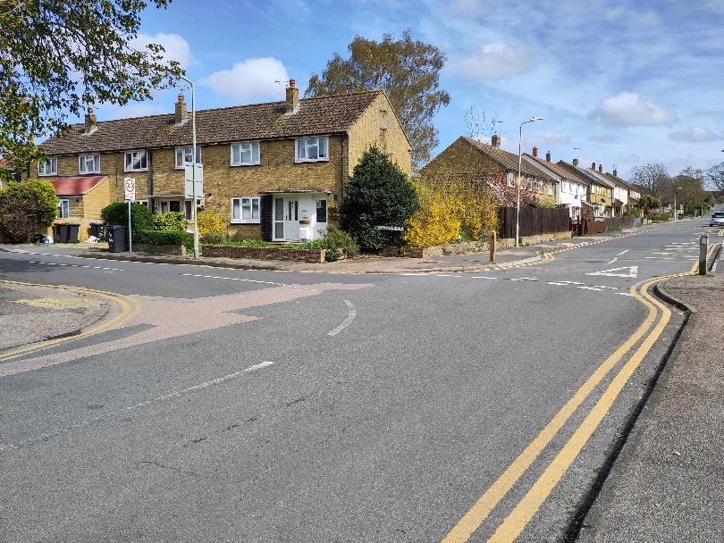
This photo shows the road markings at the junction. The centre line of the major road clearly curves round the corner to the left. The give way lines and triangle at the junction with Sussex Ave are also clearly visible. If you wish to go into Sussex Ave then this is a right turn and you must look out for, and give priority to, traffic coming down Spring Lane from the left.

This junction illustrates that it is vital for safe driving that you see, recognise and understand all the road signs and markings that you come across!!!!

