Hatched Markings and Filter Boxes

Hatched markings (diagonal lines) are often found running down the middle of a road. They are designed to separate streams of traffic and to protect traffic turning right.
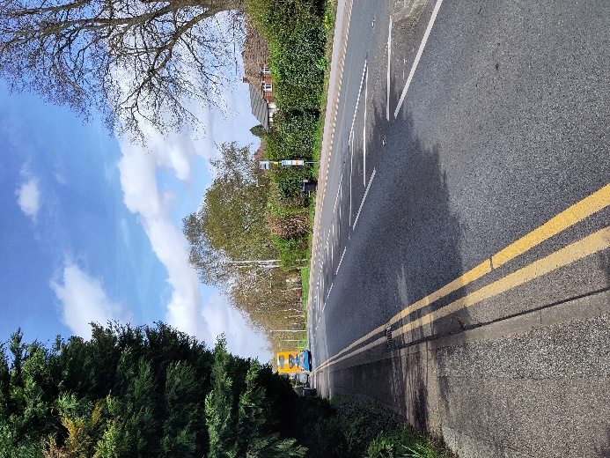
The presence of hatched markings should act as a warning to you that there may be a filter box ahead, which you should prepare to use if you are going to turn right. Filter boxes are designed to give you a safe space to wait before turning right, while at the same time allowing following traffic to flow past you on the left hand side.
