Speed Limits

Speed limits are determined by a pair of speed limit signs, one on either side of the road, and NOT by the size of the road or the type of buildings.
Think of the signs as acting like a gate into a new speed limit zone, with each sign acting as one of the gate posts. If you pass through the gate then you have entered the new zone. This speed limit remains in force until you pass through another gate, regardless of how many left or right turns you make.
Changes in speed limit often occur at junctions. Therefore it is always a good idea to look out for the signs as you approach or leave a junction or roundabout.
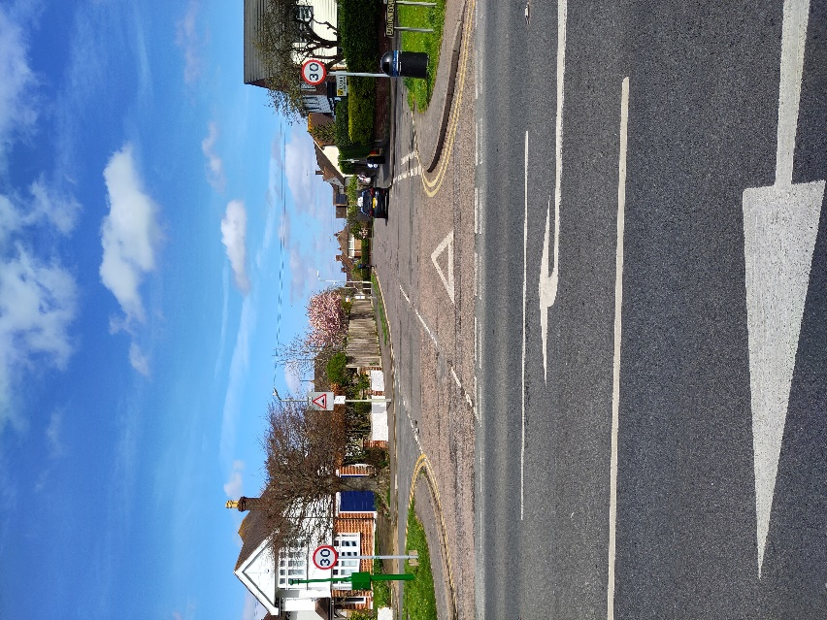
There are two default or regular speed limits in the UK. In built up areas with street lights it is 30mph, and outside of built up areas it is 60mph (70mph on motorways and dual carriageways). If there is another speed limit in force (20, 40 or 50mph) you should expect to see smaller repeater signs posted at regular intervals along the road, like the one below.
